Expt-2

Run a basic Word Count Map Reduce program to understand Map Reduce Paradigm.

# AIM:

To run a basic Word Count MapReduce program using Hadoop.

# PROCEDURE:

1. **Create Data File**:

nano word_count_data.txt

# Example content for word_count_data.txt:

Hadoop is a framework that allows for distributed processing of large data sets.

1. **Mapper Program (mapper.py)**: import sys

for line in sys.stdin: line = line.strip() words = line.split() for word in words:

print(f'{word}\t1')

# Reducer Program (reducer.py):

import sys current_word = None current_count = 0 word = None

for line in sys.stdin: line = line.strip()

word, count = line.split('\t', 1)

try:

count = int(count) except ValueError:

continue

if current_word == word: current_count += count

else:

if current_word: print(f'{current_word}\t{current_count}')

current_count = count current_word = word

if current_word == word: print(f'{current_word}\t{current_count}')

# Set Hadoop Environment:

hdfs dfs -mkdir /word_count_input

hdfs dfs -copyFromLocal word_count_data.txt /word_count_input

# Run Word Count Program:

hadoop jar $HADOOP_HOME/share/hadoop/tools/lib/hadoop-streaming-*.jar \

-input /word_count_input/word_count_data.txt \

-output /word_count_output \

-mapper mapper.py \

-reducer reducer.py

# Check Output:

hdfs dfs -cat /word_count_output/part-00000

# OUTPUT:

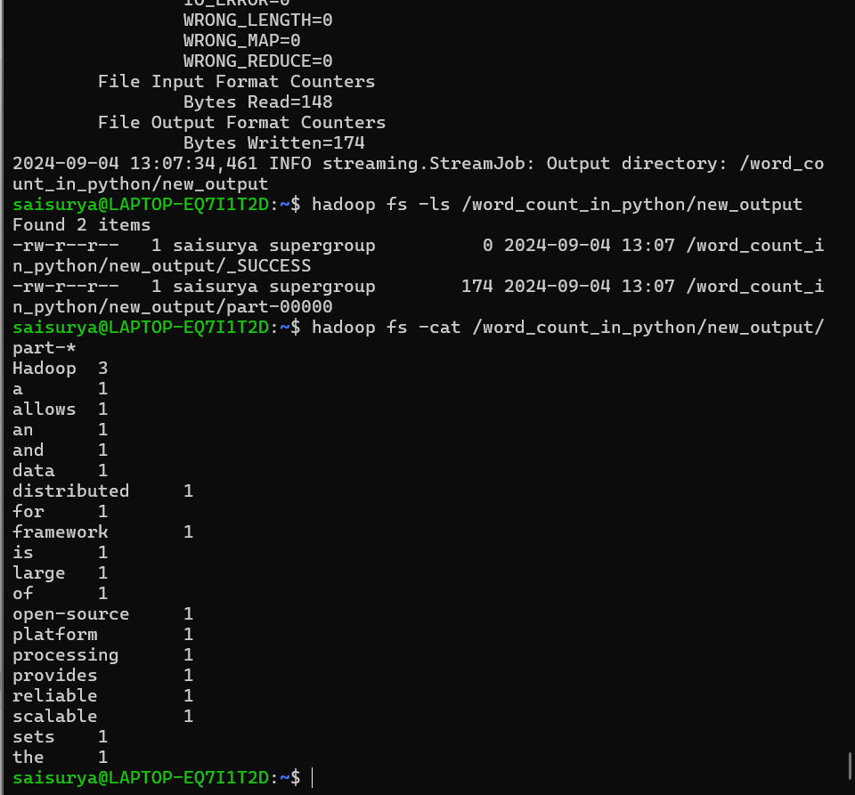

**RESULT:**

Thus, the program for basic Word Count Map Reduce has been executed successfully.